Rabbit arterial ring simulation.

KCL cumulative concentration-response
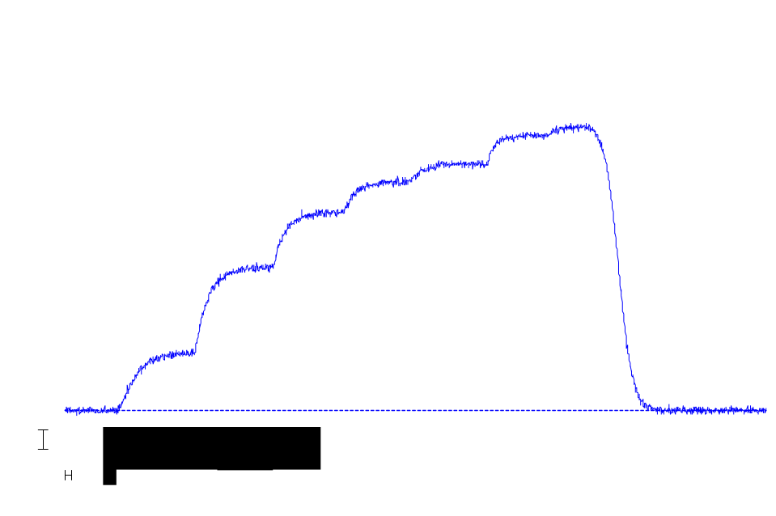

Noradrenaline cumulative concentration -response
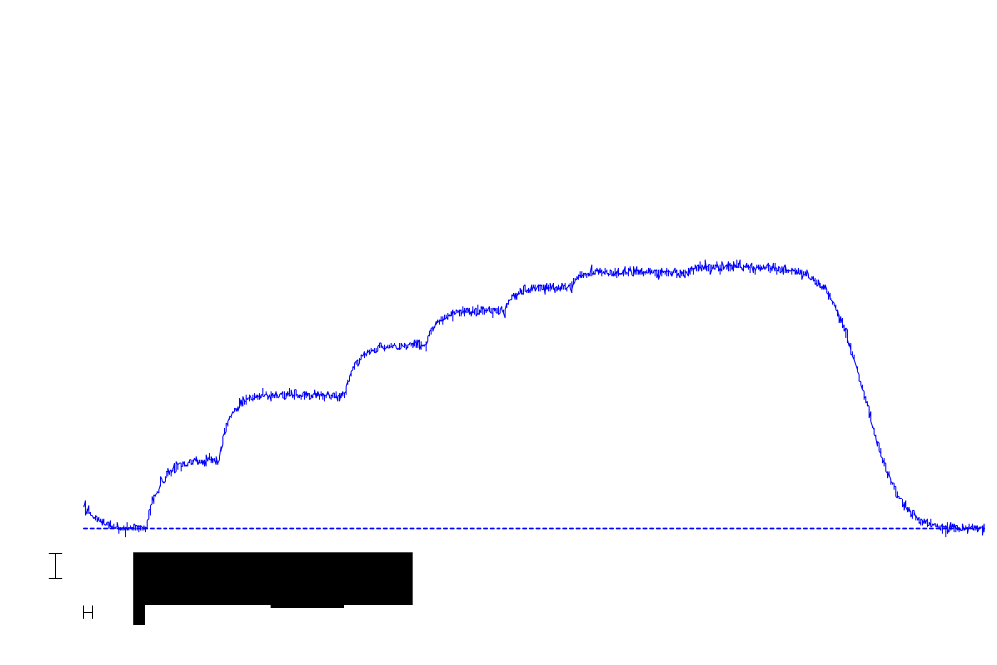

KCL and noradrenaline cumulative conc-response curves
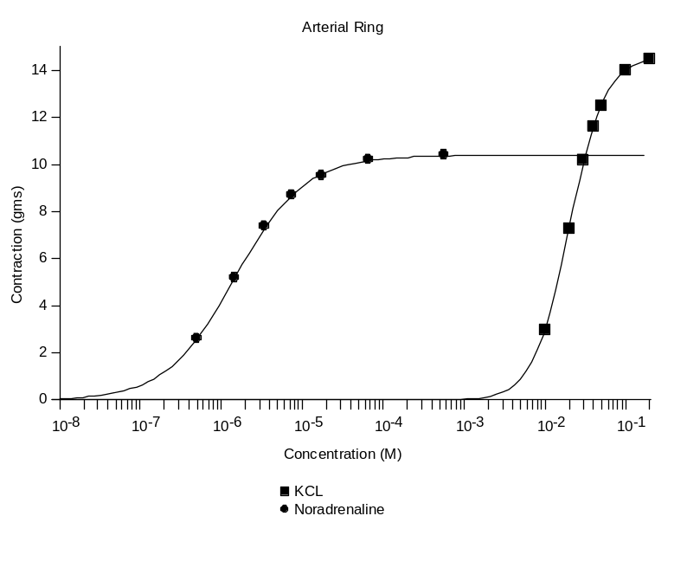
Effect of U73122 and heparin on noradrenaline response
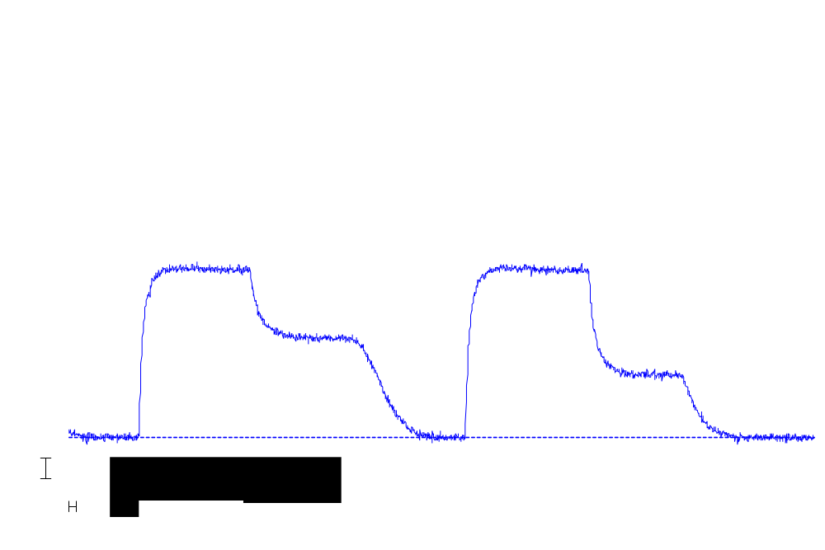

Effect of U73122 and heparin on KCL response
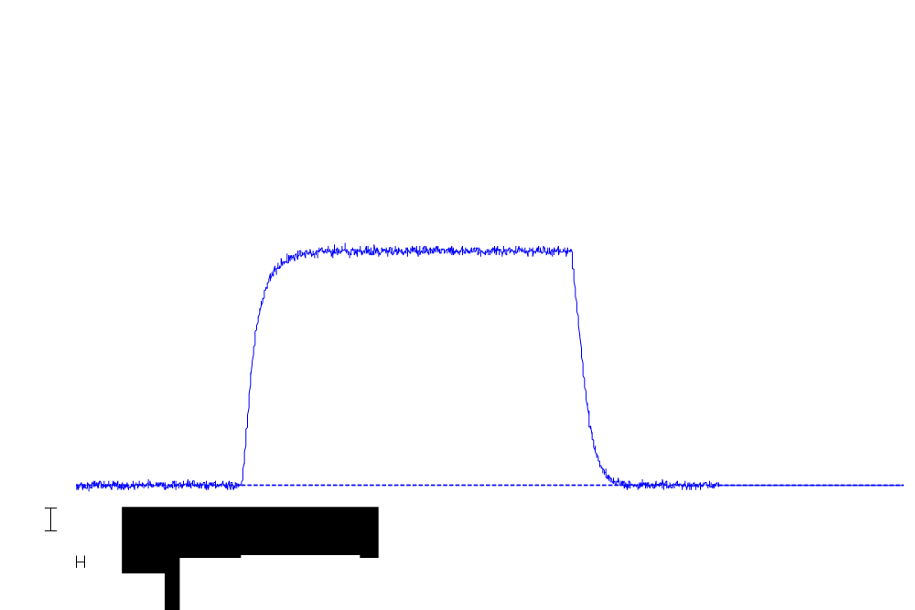

KCL and noradrenaline responses in 0 Ca Krebs.
